Introduction
Obtaining registration under Section 12AB of the Income-tax Act is a crucial milestone for charitable and religious trusts seeking income tax exemption. While the online application process through Form 10AB appears straightforward, many applications are selected for scrutiny, and the Income Tax Department may issue notices seeking clarifications, supporting documents, and explanations before granting registration. A well-structured, fact-based, and legally supported response plays a decisive role in the outcome of such proceedings.
In this article, I share a practical case study based on an actual professional assignment in which a trust's Form 10AB application was scrutinized through multiple notices issued by the Income Tax Department. By presenting the timeline of proceedings, the nature of the queries raised, the approach adopted while preparing the replies, and the key lessons learned, this article aims to provide useful guidance to Chartered Accountants, tax professionals, trustees, NGOs, and anyone involved in trust registration and compliance. Certain identifying details have been omitted to preserve client confidentiality.

Background of the Case
The client is a public charitable trust established under a duly registered Trust Deed and has been engaged in various charitable activities for over a decade. The trust held a valid registration under Section 12A of the Income-tax Act up to Assessment Year (AY) 2026–27 (i.e., Financial Year ending 31 March 2026). As per the applicable provisions, the trust was required to apply for renewal of its registration under Section 12AB by filing Form No. 10AB at least six months before the expiry of the existing registration, i.e., on or before 30 September 2025.
However, the trust filed Form No. 10AB on 1 October 2025, resulting in a delay of one day. Consequently, the Commissioner of Income Tax (Exemptions), Chennai initiated proceedings and issued two notices seeking explanations and supporting documents. Detailed replies, supported by relevant documentary evidence, were submitted in response to each notice within the prescribed time. After examining the submissions and the supporting documents, the Commissioner was satisfied with the explanations furnished and granted registration under Section 12AB by issuing Form No. 10AD.
Timeline
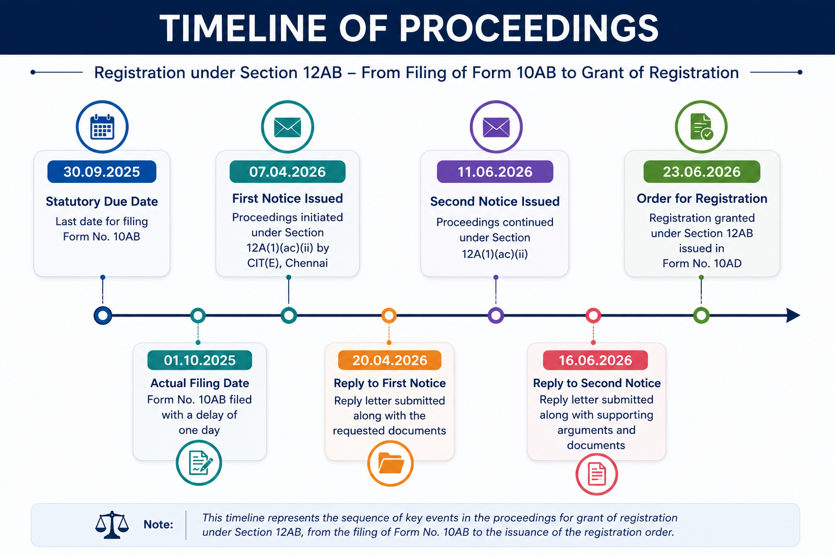

Issues Raised in the First Notice and Response Submitted
Issues Raised in the First Notice
During the course of the proceedings under Section 12A(1)(ac)(ii) of the Income-tax Act, 1961, the Commissioner of Income Tax (Exemptions), Chennai [CIT(E)] issued the first notice calling upon the trust to furnish various documents and clarifications in support of its application for registration under Section 12AB. The information and documents sought were as follows:
- A copy of Form No. 10AB filed by the trust.
- Details regarding the filing of Form No. 10AB:
  - (i) Whether the application in Form No. 10AB was filed within the time limit prescribed under the Income-tax Act, 1961.
  - (ii) If the application was filed after the prescribed due date or under a request for condonation of delay, the reasons for the delay along with supporting documentary evidence.
- A detailed note describing the nature of the trust's charitable or religious activities carried out during the last three financial years or since its inception, whichever is shorter.
- The operational names of the institutions or entities managed by the trust, including:
  - Educational Institution(s)
  - Medical Institution(s)
  - Hospital(s)
  - Place(s) of Worship
  - Any other institution or entity operated by the trust.
- Certified copies of the following documents:
  - Trust Deed, Memorandum of Association, Articles of Association, or any other instrument establishing the trust.
  - Registration certificate issued by the Registrar of Societies, Registrar of Companies, Sub-Registrar, or any other competent authority, as applicable.
  - Certified copies of all amendments or modifications made to the constitutional documents of the trust.
- Certified copies of the existing registration or approval orders, if any, including:
  - (i) Provisional registration under Section 12AB (Form No. 10AC) or provisional approval under Section 80G (Form No. 10AC).
  - (ii) Final registration under Section 12AB (Form No. 10AC or Form No. 10AD) or approval under Section 80G (Form No. 10AC or Form No. 10AD).
  - (iii) Registration or approval granted under Sections 10(23C) or 10(46), wherever applicable.
- A copy of the registration or approval granted under the earlier regime (prior to 1 April 2021) under Section 12A, Section 80G, or Section 10(23C), if applicable.
- Copies of any earlier rejection orders passed under Section 12A, Section 10(23C), or Section 80G, if any.
- Certified copies of the trust's financial statements for the Financial Years 2024–25, 2023–24, and 2022–23 (or from the date of inception, whichever is shorter), including:
  - Income and Expenditure Account
  - Balance Sheet
  - Audit Report
- Contact details of the trust and its authorised representative, including:
- Name, telephone number, and e-mail address of the Managing Trustee.
- Name, telephone number, and e-mail address of the Authorised Representative / Chartered Accountant.
Response Submitted Against the First Notice
A comprehensive reply was prepared and submitted in response to the first notice issued by the Commissioner of Income Tax (Exemptions), Chennai. The reply was drafted in a structured and professional manner to address all the information and documents sought by the Department.
For ease of reference and better presentation, the submission was divided into the following three sections:
- Acknowledgement of Receipt of Notice

- Our Submissions

- Prayer and Conclusion
The complete reply submitted before the Commissioner of Income Tax (Exemptions), Chennai may be downloaded from the link provided below:
📄 Download the Reply Submitted Against the First Notice (PDF)

Issues Raised in the Second Notice and Response Submitted
Issues Raised in the Second Notice
In the second notice, the Commissioner of Income Tax (Exemptions), Chennai [CIT(E)] referred to the provisions of Section 12A(1)(ac)(ii) of the Income-tax Act, 1961, which require a trust or institution holding registration under Section 12AB to file an application for renewal in Form No. 10AB at least six months prior to the expiry of the existing registration.
The CIT(E) observed that the trust had not filed Form No. 10AB within the prescribed statutory time limit and, therefore, called upon the trust to explain:
- The reasons for the delay in filing the application for renewal; and
- Why the application filed in Form No. 10AB should be admitted and processed despite the delay.
Response Submitted Against the Second Notice
A detailed reply was prepared and submitted in response to the second notice. The reply addressed the legal and factual issues raised by the CIT(E), explained the circumstances leading to the one-day delay in filing the application, and requested the Commissioner to consider the submissions in the interest of justice and to process the application in accordance with law.
For better presentation and clarity, the reply was organised into the following three sections:
- Acknowledgement of Receipt of Notice
- Our Submissions
- Prayer and Conclusion
The complete reply submitted before the Commissioner of Income Tax (Exemptions), Chennai may be downloaded from the link provided below:
📄 Download the Reply Submitted Against the Second Notice (PDF)

Legal Provisions and Judicial Precedent Relied Upon
The following statutory provisions and judicial precedent were relied upon while preparing the replies submitted before the Commissioner of Income Tax (Exemptions), Chennai:
- Section 12A(1)(ac)(ii) of the Income-tax Act, 1961
This provision mandates that a trust or institution already registered under Section 12AB shall file an application for renewal of its registration in Form No. 10AB at least six months prior to the expiry of the existing registration.
- First Proviso to Section 12A(1)(ac)
The first proviso empowers the Principal Commissioner of Income Tax (PCIT) or Commissioner of Income Tax (CIT) to condone the delay in filing an application for registration or renewal, subject to being satisfied that there was a reasonable cause for the delay.
- Rule 17A of the Income-tax Rules, 1962
Rule 17A prescribes the forms, procedure, and supporting documents required for obtaining registration or renewal of registration under Section 12AB of the Income-tax Act, 1961.
- Judicial Precedent – “Sunder Nagar Satsang Sabha v. Commissioner of Income Tax (Exemptions)”
Reliance was placed on the decision of the Hon'ble Income Tax Appellate Tribunal, Mumbai Bench, wherein the Tribunal held that the delay in filing the application could be condoned in appropriate circumstances. In that case, the Hon'ble ITAT directed the Commissioner of Income Tax (Exemptions) to reconsider the application after condoning a delay of 16 months, thereby recognising that procedural delays should not defeat a genuine claim for registration where sufficient cause is established.
The order copy of the Tribunal passed by Income Tax Appellate Tribunal, Mumbai Bench is available in the link: https://drive.google.com/file/d/1MRKe7ZASQKW34LJfSijk7OBHK0Yp7BXr/view?usp=drive_link
Disclaimer: The attached ITAT order is reproduced from the official records of the Income Tax Appellate Tribunal for educational and informational purposes only. Any personal or sensitive information, where necessary, has been redacted. Readers should refer to the official records for the complete and authoritative text. The document remains an official judicial record.

Outcome of the Proceedings
After carefully examining the submissions, supporting documents, and legal contentions furnished in response to both notices, the Commissioner of Income Tax (Exemptions), Chennai was satisfied with the explanations provided by the trust. Accordingly, the Commissioner passed an order granting registration under Section 12AB of the Income-tax Act, 1961, and issued the registration order in Form No. 10AD. This case demonstrates that a delay in filing an application, by itself, does not necessarily result in rejection. Where the applicant establishes sufficient cause for the delay and supports the application with complete documentary evidence and well-reasoned legal submissions, the competent authority may exercise the powers available under the Act to consider the application on its merits. The proceedings also underscore the importance of responding to departmental notices in a timely, comprehensive, and legally substantiated manner. A carefully drafted reply, supported by relevant statutory provisions, judicial precedents, and documentary evidence, can significantly influence the outcome of the proceedings.

Key Lessons for Trusts
The present case offers several important lessons for charitable and religious trusts seeking registration or renewal under Section 12AB of the Income-tax Act, 1961:
- Monitor statutory due dates carefully. Trusts should maintain a compliance calendar to ensure that applications for registration or renewal are filed well within the prescribed time limits.
- Do not ignore departmental notices. Every notice issued by the Income Tax Department should be responded to promptly, accurately, and within the stipulated time.
- Maintain complete and updated records. Trusts should preserve constitutional documents, financial statements, activity reports, audit reports, and other supporting records, as these are frequently called for during registration proceedings.
- Provide issue-wise and evidence-based replies. Replies should directly address each observation raised by the Department and be supported by relevant documentary evidence and legal provisions wherever applicable.
- Rely on the applicable legal framework. Appropriate reference to statutory provisions, rules, circulars, and judicial precedents can significantly strengthen the credibility of the submissions.
- A procedural delay is not always fatal. Where a genuine and reasonable cause exists, the delay should be properly explained with supporting evidence. The competent authority has the discretion, in appropriate cases, to consider such explanations in accordance with the provisions of the Act.
- Seek professional assistance whenever necessary. Registration proceedings under Section 12AB involve both factual and legal aspects. Professional guidance can help ensure that applications, supporting documents, and replies are prepared in a comprehensive and legally sustainable manner.
This case demonstrates that thorough documentation, timely compliance, and well-reasoned legal submissions can substantially improve the prospects of obtaining registration under Section 12AB. Trusts should therefore treat every notice as an opportunity to clarify their position rather than merely as a procedural formality.

Conclusion
This case demonstrates that while timely compliance with the provisions of the Income-tax Act is essential, a genuine procedural delay, supported by valid reasons and well-documented legal submissions, need not result in the rejection of a registration application. A comprehensive, evidence-based, and legally reasoned response to departmental notices can significantly contribute to a favourable outcome. Trusts should therefore ensure timely compliance and adopt a diligent approach in all proceedings before the Income Tax Department.

Disclaimer
This case study is based on an actual professional assignment handled by the author and is published solely for educational and informational purposes. Certain facts, dates, and other identifying details have been modified or omitted to preserve client confidentiality. The views expressed herein are based on the facts and legal provisions applicable at the time of the proceedings and should not be construed as legal, tax, or professional advice. Readers are advised to refer to the latest statutory provisions, judicial pronouncements, and official notifications or seek professional advice before acting on any information contained in this article.

Frequently Asked Questions (FAQs)
1. What is Form No. 10AB?
Form No. 10AB is the prescribed application form used by charitable or religious trusts and institutions to apply for registration, renewal of registration, or conversion of provisional registration into regular registration under Section 12AB of the Income-tax Act, 1961.
2. When should Form No. 10AB be filed for renewal of registration?
Where a trust already holds registration under Section 12AB, the application for renewal is generally required to be filed at least six months before the expiry of the existing registration, subject to the provisions applicable under the Income-tax Act, 1961.
3. Can the Income Tax Department issue notices during the registration process?
Yes. The Commissioner of Income Tax (Exemptions) may issue notices seeking clarifications, supporting documents, financial statements, activity reports, or any other information necessary to verify the genuineness of the trust and its activities before granting registration.
4. What documents are generally required during the proceedings?
The Department may call for documents such as the Trust Deed, registration certificates, financial statements, audit reports, activity reports, existing registration orders, Form No. 10AB, and other supporting documents depending on the facts of each case.
5. Can a delay in filing Form No. 10AB result in rejection of the application?
A delay may invite scrutiny by the Department. However, where sufficient cause exists and the delay is properly explained with supporting evidence, the competent authority may consider the application in accordance with the provisions of the Income-tax Act.
6. Is it necessary to respond to every query raised in the notice?
Yes. Every observation or query raised by the Department should be addressed specifically and supported by relevant documentary evidence and, wherever appropriate, applicable legal provisions or judicial precedents.
7. What is the key takeaway from this case study?
The case demonstrates that careful preparation, complete documentation, timely responses, and legally supported submissions can play a significant role in achieving a favourable outcome during registration proceedings under Section 12AB.
8. Does this article constitute legal or tax advice?
No. This article is published solely for educational and informational purposes. The facts discussed relate to a specific case, and readers should seek professional advice based on their own circumstances before taking any action.
9. Where can I download the notices, reply letters, and registration order referred to in this case study?
For educational purposes, the notices, reply letters, and the registration order discussed in this article are available through the download links provided in the respective sections of this blog.

